**Game Engine Foundations**

**Lab Three**

For this lab, you are requested to do the following:

1 – Download the code that we developed in class last week.

2 – Verify that you have a solid understanding of the algorithm, otherwise, ask questions about any parts that you are confused and I’ll sit with you to resolve the confusion.

3 – Modify the code so that pressing ‘T’ on the keyboard provides a top view of the 3D-World. In this case, we can still travel in our 3D-World using ‘WASD’ keys, but, our view would be top view. This is illustrated below.

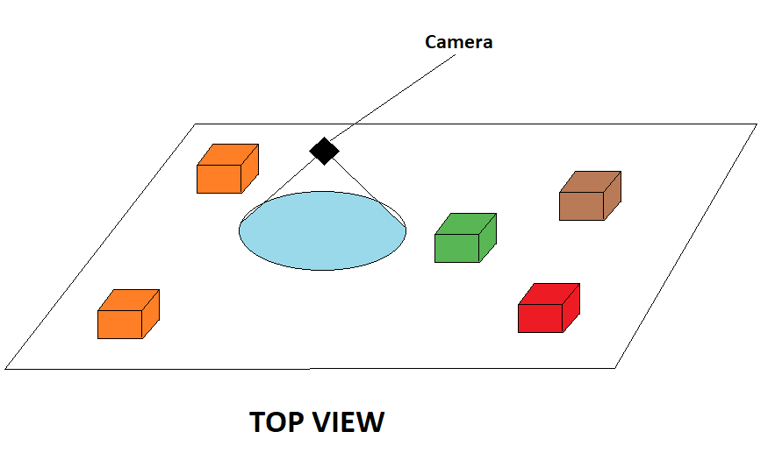

**Looking for more challenge?**

**Make it so that you can swap between the two cameras. Pressing ‘T’ provides you the top view and pressing ‘P’ provides the perspective view.**